**CS – 330 Reflection**

DeAnna Lee

My scene:

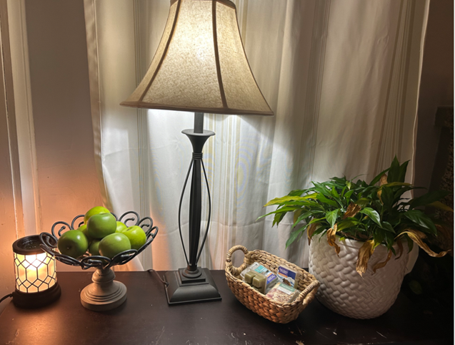

I took a picture of a scene in my home. I chose to program the lamp first. I wanted to make sure I understood how the techniques in the lessons worked on the lamp solely before adding more shapes. Later, I added the warming light and the potted plant but was challenged with the textures. I tried copying the real picture to obtain the pattern on both objects with no avail. My goal was to add the apples and the fruit container once I was comfortable with the code for the lamp.

I experienced challenges with the lighting and camera direct. I experimented with different shades of color and different directions of light. Unfortunately, I was unable to accomplish the same lighting in the photo. My goal was to have light streaming from the lamp and a combined (Phong) light illuminating from the warming lamp. To accomplish this properly, I would need to update the texture on the warming lamp to a soft amber without the textural wrapping. This led to how the code is reusable.

I could reuse code to create new objects or change the textures on the objects by updating the ‘name tag’ and the mesh call to draw. The RenderScene Function pulled everything together to create the positioning and textures of the objects.

The most challenging part for me was lighting. However, I was able to reuse code to create new lighting. The SetupSceneLights Function uses a matrix to maneuver the color, position, focal strength, and light intensity. I was able to experience the power of this function by toying with the variables using positive and negative numbers. My goal was to achieve a soft amber light with a combination of the diffuse and specular light where needed.

Overall, time was my biggest problem. I experienced many techniques in this course and learned a lot about shapes, x-y-z position, camera placement, color, and light. I look forward to building on this knowledge in the future.